STUDENT NAME:

ASSIGNMENT:

I. Code File and Executable: The original binary file that you are provided with should be converted to a fully running program in C that functions as described in your commented code. For grading purposes, you must submit your code as both an executable and a Microsoft Word document.

A. Convert the binary file into assembly code. [CS-410-01]

I used a default tool in Linux to check the components of the binary file provided. The gdb tool allow one to disassemble a binary file, check its method and all its code in assembly language. I used the below steps to analyze the binary file.

Step One

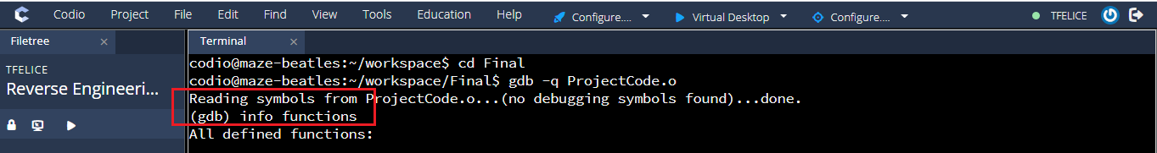

Results

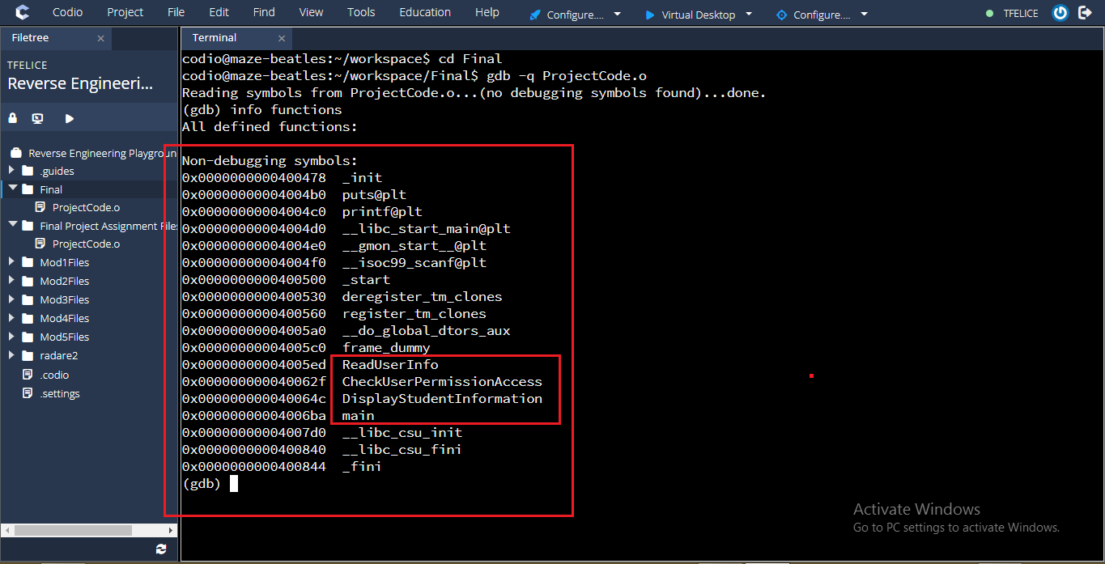

The above command gives the following details. Which are the functions or methods contained in the application.

* ReadUserInfo
* checkUserPermissionAccess
* DisplayUserInformation
* Main

## **Step Two: Disassembling functions**

I also utilized the gdb tool to disassemble the binary file. This gave me more details about each function.

The command to disassemble the function is show below.

Command: ***disas ReadUserInfor***

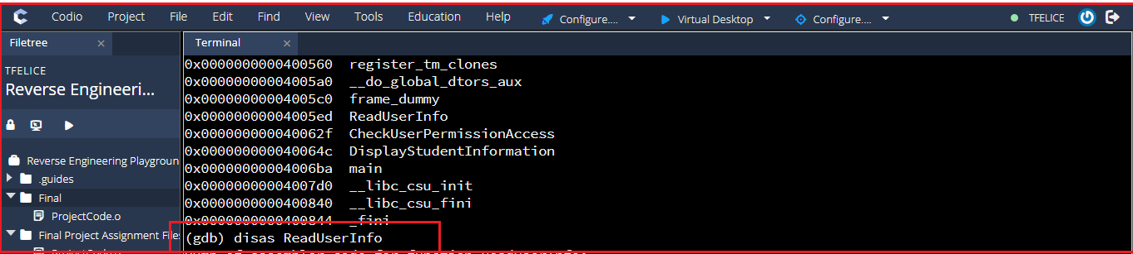

Results.

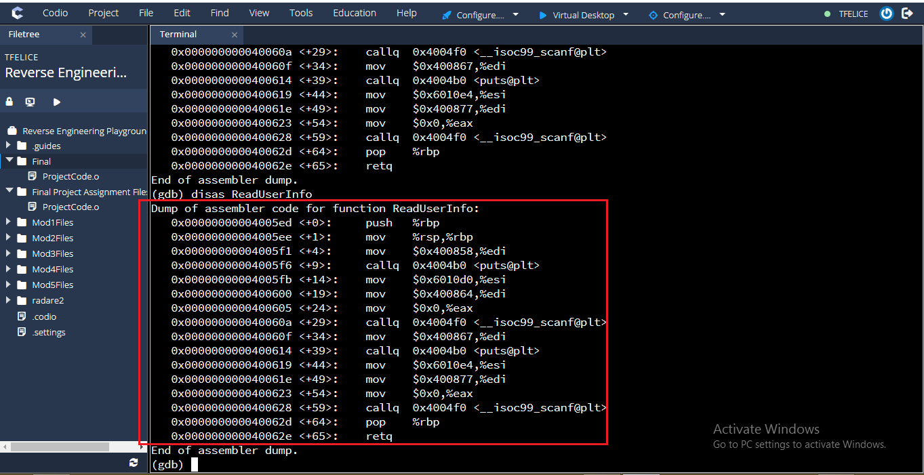

I also used other commands in gdb to check the details inside each function. We can use gdb to check passwords and user names that were hard coded in the binary file. The image below shows the command in use.

Examining some value in the function using x/s

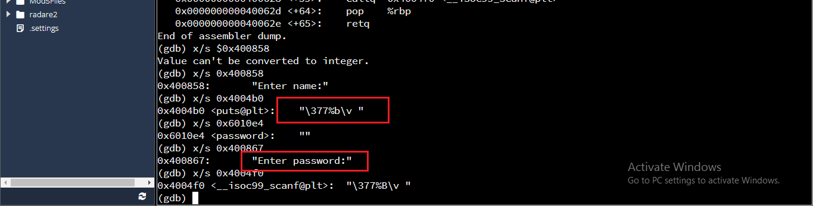

Assembly Code.

|  |  |
| --- | --- |
| Assembly Code | Explanation |
| push %rbp  mov %rsp,%rbp  mov $0x400858,%edi  callq 0x4004b0 <puts@plt> | Start of the function  [mov command] Moves value in $0x400858 into %edi,  The last statement prints the string in address edi |
| mov $0x6010d0,%esi  mov $0x400864,%edi  mov $0x0,%eax  callq 0x4004f0 <__isoc99_scanf@plt> | This block will allow user to enter data into the application when running.  It will prompt user to enter the name and the password at the starting point of the program execution.  The last line calls scanf which allow user to enter an input. |
| mov $0x400867,%edi  callq 0x4004b0 <puts@plt>  mov $0x6010e4,%esi  mov $0x400877,%edi  mov $0x0,%eax | From my analysis in the images above, I found out that the string Enter password is in 0x400867 is enter password. This means that the program is responsible for password from user. |
| callq 0x4004f0 <__isoc99_scanf@plt>  pop %rbp  retq | The scanf allow user or the program to get an input from user. It is called here to get the user password. |

**Disassembling CheckUserPermissionAccess Function**

Just like in the previous function,

Disas CheckUserPermissionAccess.

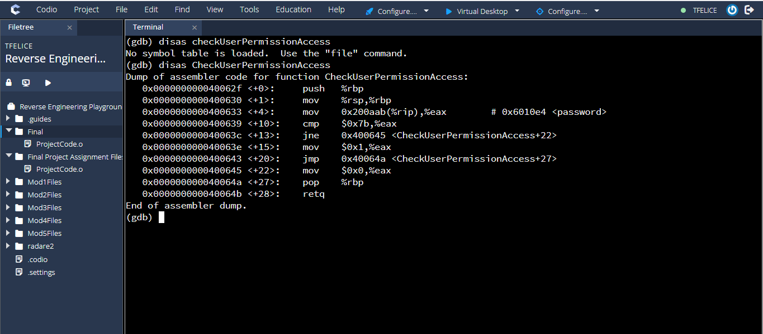

Checking this functions deeply, we get more details about the functions. These include string name used and some contents of the variables used. The image below shows some of the contents revealed.

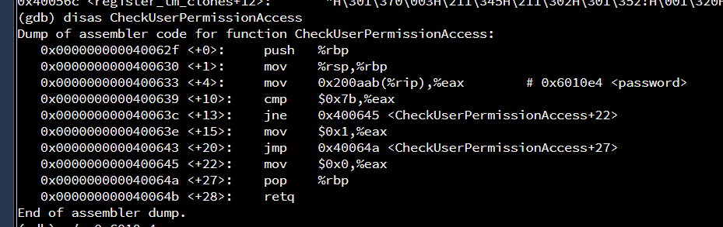

Assembly Code

|  |  |
| --- | --- |
| Assembly Code | Explanation |
| push %rbp  mov %rsp,%rbp | This is the starting point of the application. |
| mov 0x200aab(%rip),%eax # 0x6010e4 <password>  cmp $0x7b,%eax  jne 0x400645 <CheckUserPermissionAccess+22> | [mov] the value held in memory with address 0x200aab(%rip) is moved to address eax  [cmp] this is comparison command. It compares value in eax with value $0x7b,%eax  This statements says that jump if not equal, the program execution will jump to line 0x400645 in a case where value $0x7b is not equal to value in %eax |
| mov $0x1,%eax  jmp 0x40064a <CheckUserPermissionAccess+27>  mov $0x0,%eax | This line moves 1 into eax address. This happens when the comparison above is true the values are equal. This means that the method return s one when user enter the correct password, a means of showing that password is correct, otherwise the program exits by returning a zero |

Disassembling DisplayStudentInformation Function

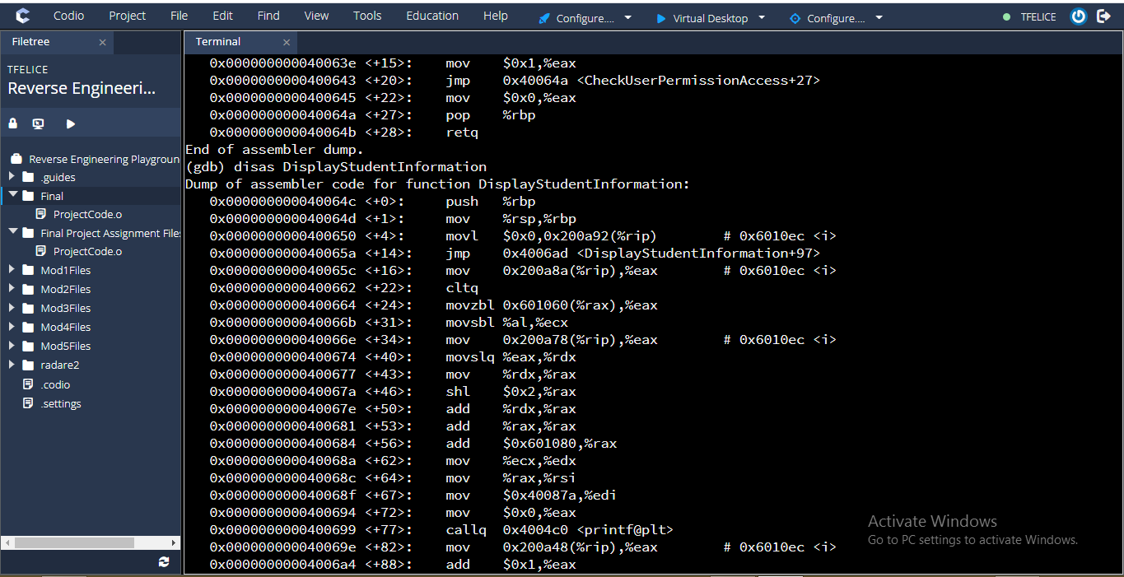

Checking contents using x/s command. This wil give us the contents of some variables. Like the below gives us the name of one of the students. Jim.

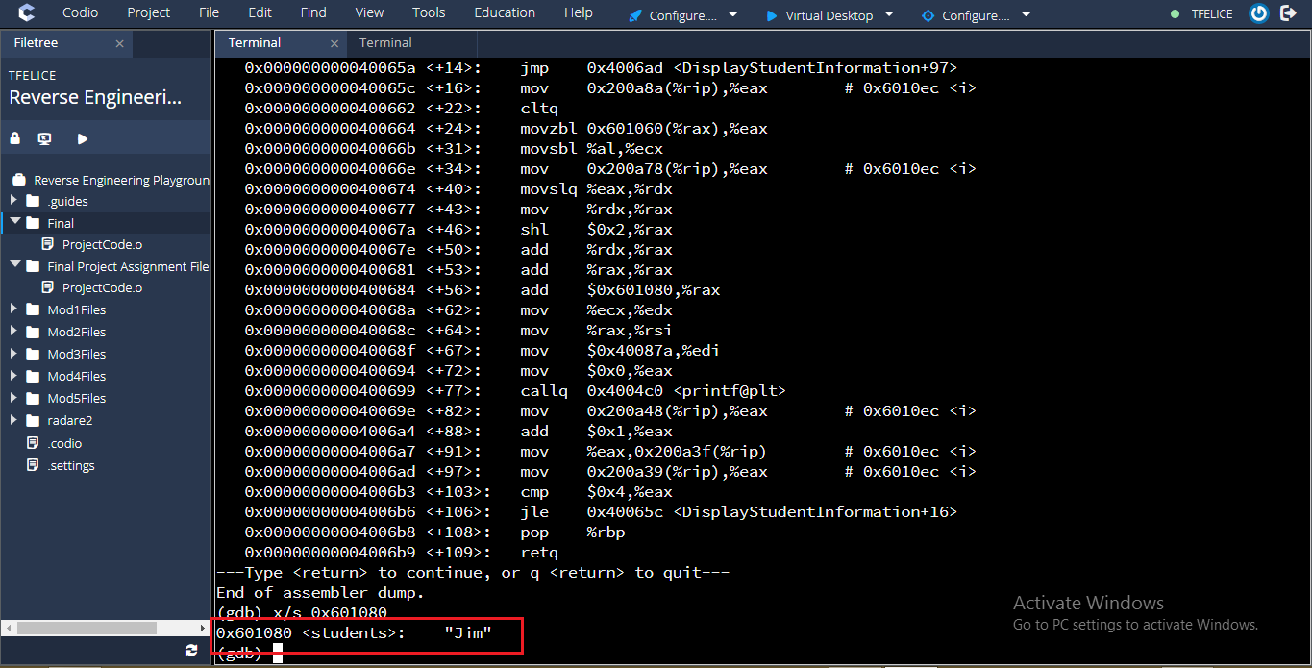

This gives us a hint that the student’s names are held in either a string in the code or an array.

We can also say or expect an array of students grades, and to display them a loop may have been used to read the grades and the student names.

Assembly Code

|  |  |
| --- | --- |
| Assembly Code | Description |
| Line 0 to Line 14 | |
| push %rbp  mov %rsp,%rbp  movl $0x0,0x200a92(%rip) # 0x6010ec <i>  jmp 0x4006ad <DisplayStudentInformation+97> | Start of the program  Initialize the counter for the loop  Ask the program to jump, which makes the program to move to line 97 [from the image above] |
| Line 97 to 106 | |
| mov 0x200a39(%rip),%eax # 0x6010ec <i>  cmp $0x4,%eax  jle 0x40065c <DisplayStudentInformation+16> | A value is moved into address eax.  The value is then compared by 4 [$0x4]  If the value is less than [jle] program will jump to line 16  This reveals a loop as it can be done in C as shown below  WHILE counter < 4:  JUMP TO LINE 16  ADD 1 TO COUNTER  ELSE  LOOP EXITS |
| From Line 16 to 91 | |
| mov 0x200a8a(%rip),%eax # 0x6010ec <i>  cltq  movzbl 0x601060(%rax),%eax  movsbl %al,%ecx  mov 0x200a78(%rip),%eax # 0x6010ec <i  movslq %eax,%rdx  mov %rdx,%rax  shl $0x2,%rax  add %rdx,%rax  add %rax,%rax  add $0x601080,%rax  mov %ecx,%edx  mov %rax,%rsi  mov $0x40087a,%edi  mov $0x0,%eax | Moves value in address 0x200a8a(%rip) into %eax. This represents the array of names as we have seen in the images above.  char *students[] = {"Jim","Tom","Ben","Alice","Ruby"};  [movsbl %al,%ecx]  They are then moved into ecx  [mov 0x200a78(%rip),%eax ]  Further the grades are loaded into eax  char grades[] = "ACCDF";  From the analysis above, I found out that, during each loop, a student name is displayed. This means that, when counter is 1, the first student at index 1 will be displayed. That way all the students will be displayed |
| callq 0x4004c0 <printf@plt>  mov 0x200a48(%rip),%eax # 0x6010ec <i>  add $0x1,%eax  mov %eax,0x200a3f(%rip) # 0x6010ec <i>  mov 0x200a39(%rip),%eax # 0x6010ec <i>  cmp $0x4,%eax  jle 0x40065c <DisplayStudentInformation+16> | .This blocks prints the strings for grades and the student name.  As show in the pseudocode, this block will further increment the counter with 1 as long as it’s less than 4.  [cmp $0x4,%eax]  The counter will then be compared to 4 if it’s less than 4, then the loop continues, otherwise the loops stops by jumping to line 16 |
| pop %rbp  retq | Program exits |

**Disassembling the main function**

The main is the starting point of the function. The program execution starts here and all the other functions will be called after this function.

The below image shows the contents of the main function.

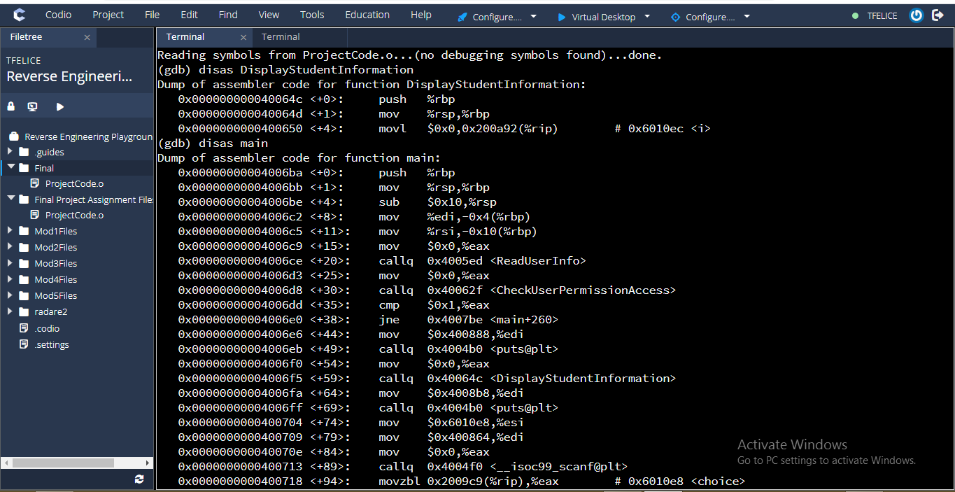

Continuation

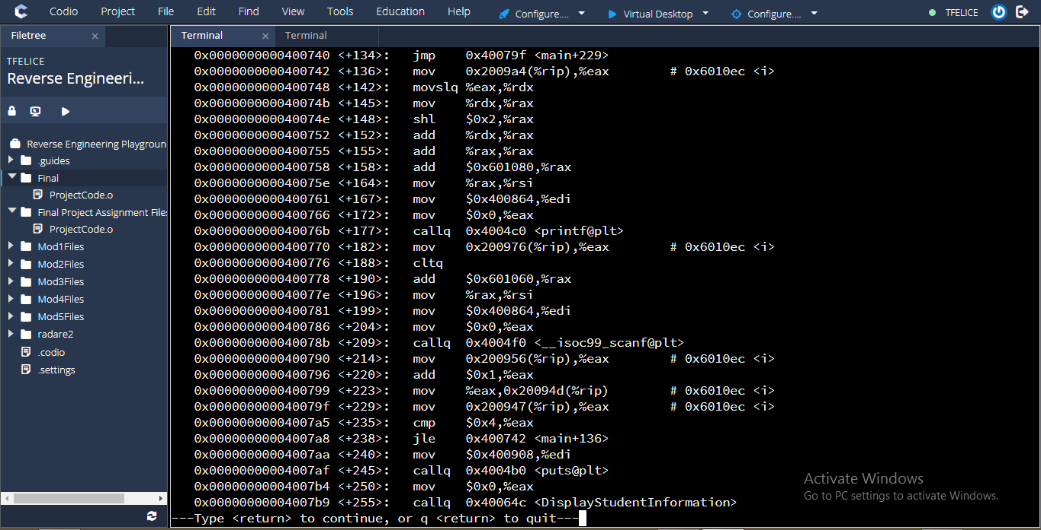

Assembly Code and Its Description

|  |  |
| --- | --- |
| Assembly Code | Explanation |
| Block One | |
| push %rbp  mov %rsp,%rbp | The start of the main progrram |
| Block Two | |
| sub $0x10,%rsp  mov %edi,-0x4(%rbp)  mov %rsi,-0x10(%rbp)  mov $0x0,%eax | Program initialization.  mov %edi,-0x4(%rbp) Moves value which resides in edi into -0x04(rpb)  mov %rsi,-0x10(%rbp) moves value in address rsi into ,-0x10(%rbp)  mov $0x0,%eax Moves value 0 into eax |
| Block Three | |
| callq 0x4005ed <ReadUserInfo> | This line calls method ReadUserInfor.  This will allow user to enter user name and password |
| Block Four | |
| mov $0x0,%eax  callq 0x40062f <CheckUserPermissionAccess> | Move 0 to address eax  This line calls CheckUserPermissionAccess Method. |
| Block Five | |
| cmp $0x1,%eax  jne 0x4007be <main+260>  mov $0x400888,%edi  callq 0x4004b0 <puts@plt>  mov $0x0,%eax | As stated earlier, the method CheckUserPermission will return 1 for success, 0 for fail. Therefore, once the method exits, the returned vaue will be compared to 1  cmp $0x1,%eax  If they are equal the the program continues otherwise it will jump to line 260  It will the print string which is in edi, the finally move 0 into address eax |
| Block 6 | |
| callq 0x40064c <DisplayStudentInformation> | This code calls the function DisplayStudentInformation,  this method display the student names and their grades. |
| Block 7 | |
| mov $0x4008b8,%edi  callq 0x4004b0 <puts@plt>  mov $0x6010e8,%esi  mov $0x400864,%edi  mov $0x0,%eax | This block gives a choice to the user. It will prompt user for details. This block will load strings before displaying them on the seen.  mov $0x6010e8,%esi and mov $0x400864,%edi  Moves values to esi and edi respectively. |
| Block 8 | |
| callq 0x4004f0 <__isoc99_scanf@plt>  movzbl 0x2009c9(%rip),%eax # 0x6010e8 <choice> | This block allow user to enter his/her choice. |
| Block 9 | |
| cmp $0x59,%al  jne 0x4007be <main+260> | Then the program compare the value entered with another hardcoded value, if they match then user is allowed to adjust records else the program will jump to line 260, where it will exit. |
| mov $0x4008d8,%edi  mov $0x0,%eax  callq 0x4004c0 <printf@plt>  movl $0x0,0x2009ac(%rip) | A value is moved to %edi  Using gdb, as I have shown in the image above, it gives the appropriate strings that will be displayed when the printf method is called.  (gdb) x/s 0x4008b8  0x4008b8: "Adjust grades for students?"  (gdb) x/s 0x6010e8  0x6010e8 <choice>: ""  (gdb) x/s 0x4008d8  0x4008d8: "Enter the GPA for students one at a time\n "  This strings are displayed to the user to allow one to change the grades of the students |
| jmp 0x40079f <main+229>  mov 0x2009a4(%rip),%eax  movslq %eax,%rdx  mov %rdx,%rax  shl $0x2,%rax  add %rdx,%rax  add %rax,%rax  add $0x601080,%rax  mov %rax,%rsi  mov $0x400864,%edi | The firs line will make the program to jump to line 229.  This block will also display the student’s records on the screen. Each student data is display in each program loop. |
| mov $0x400864,%edi  mov $0x0,%eax  callq 0x4004c0 <printf@plt>  mov 0x200976(%rip),%eax # 0x6010ec <i>  cltq  add $0x601060,%rax  mov %rax,%rsi  mov $0x400864,%edi  mov $0x0,%eax  callq 0x4004f0 <__isoc99_scanf@plt>  mov 0x200956(%rip),%eax # 0x6010ec <i>  add $0x1,%eax  mov %eax,0x20094d(%rip) # 0x6010ec <i>  mov 0x200947(%rip),%eax # 0x6010ec <i>  cmp $0x4,%eax  jle 0x400742 <main+136>  mov $0x400908,%edi  callq 0x4004b0 <puts@plt> | This block of code is responsible for allowing a user to change the existing records.  The loop created here iterate thorough the records allowing the user to enter new records.  This bloc of code controls the loop, this will allow all the records to be edited in the string of student’s grades. |
| mov $0x0,%eax  callq 0x40064c | Once user enters the records for each student, then the DisplayStudentInformation method is called to display the edited records. |
| Last Block | |
| mov $0x0,%eax  leaveq  retq | The program terminates. |

**Translated C Code.**

**Just Like other C programs, we have variable declaration**



**DisplayStudentInformation**



ReadUserInfo



**Main Method**



**CheckUserPermissionAccess**

